

INDIA’S AGRICULTURAL

CROP PRODUCTION ANALYSIS

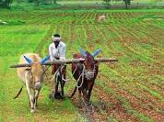

**INTRODUCTION**

**Overview**

A common agricultural practice followed by worldwide farmers to grow and produce crops to use as food and fibre.



Crop production is the basis for providing the livestock industry with feed, and the population with food.

**Problem Definition & Design Thinking**

**Empathy Map**

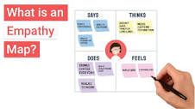

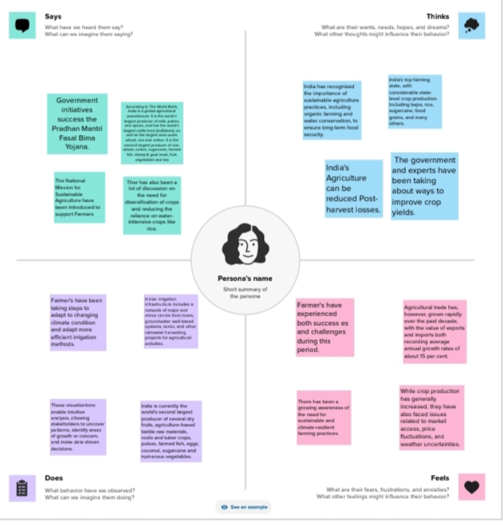

**Brainstroming Map**

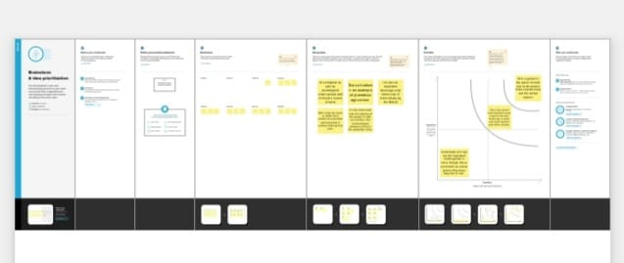

**ADVANTAGES**

* **Food for Human beings:** It provides food that can be consumed by human beings. These include vegetables, fruits and meat.
* **Food for Animals:** Animals also feed on food grown through agriculture for instance hay, fodder, silage and more.
* **National Revenue:** Many governments especially in developing countries earn most of their income from agricultural.

**APPLICATIONS**

As the competition in agriculture has been increasing day by day, business companies in the agricultural sector have started to implement predictive analytics in their operational area.

**CONCLUSION**

The Indian economy is an agro-economy and depends highly on the agricultural sector. Supporting the Indian Economy, the agricultural sector also supports the industrial sector and trade in imports and exports.

**FUTURE SCOPE**

Due to globalization, increase in household incomes and health consciousness the demand for fruits and vegetables, dairy products, fish and meat is going to increase in future.

THANK YOU